BUY A BRICK PROGRAM
LEAVE YOUR MARK IN HISTORY!

Memorial Brick Costs & Options
4” X 8” Brick Paver (3 lines) $150
8” X 8” Brick Paver (6 lines) $250
8” X 8” Brick Paver (6 lines) $500 Corporate

4” X 8” (20 spaces per line –3 line limit)
8” X 8” (20 spaces per line –6 line limit)
8” X 8” With Logo (20 spaces per line –3 line limit)

There is also clip art available at no additional charge! For additional information on what is available please Contact Jennifer Stemmley,
at jenny@fundraisingbrick.com or call 573-486-5515

Compose your Memorial Message Below

Line 1
Line 2
Line 3
Line 4
Line 5
Line 6

Name: _______________________________________________
Address:_______________________________________________
_______________________________________________
Phone: _______________________________________________
Email: ________________________________________________
Check Money Order Visa MC Discover
Credit Card #:

Exp. Date: ________________________________________________
Signature:_______________________________________________
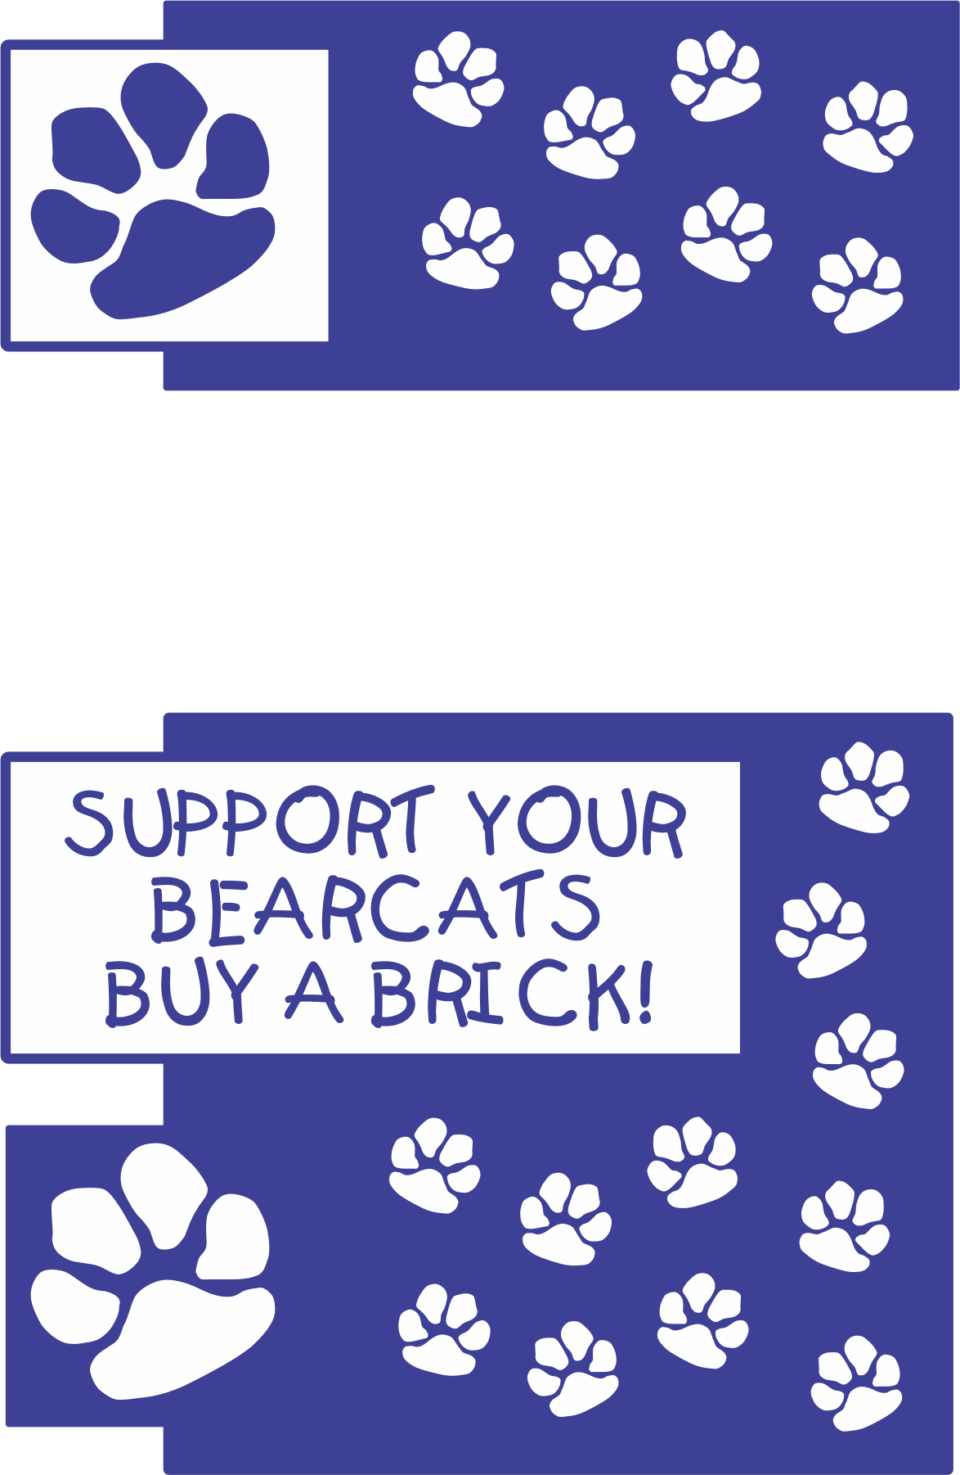
Design your font cover here

LITTLE BEARCAT
ELEMENTARY

Clipart Selection – If you are not offering Clipart use this section for text for more pictures, logos, or graphics.

Insert a picture, logo, graphic, or text here.

Brick Selection Options
Insert Sample Pictures of Bricks or Layouts Here

