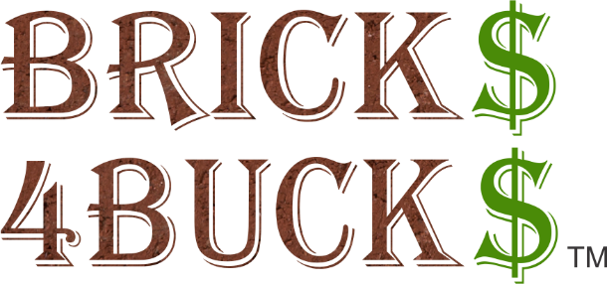
Insert pictures of engraved bricks that you are offering to your donors. Contact Fundraising Brick to receive your FREE engraved brick images.
Insert pictures of engraved bricks that you are offering to your donors. Contact Fundraising Brick to receive your FREE engraved brick images.

FUNDRAISING PROJECT NAME HERE
BUY A BRICK PROGRAM

CUSTOMIZE THIS SECITON TO FIT YOUR ORGANIZATIONS NEEDS.
ORDER NOW AT
http://www.fundraisingbrick.com/online-orders/
Select “Your Organization Name Buy A Brick Campaign”
OR
Complete Order form below and return to the following address:
Organization Name, Address
Make Checks Payable to: Organization Name
Please direct questions to Jennifer Stemmley at 555.555.5555 or email jenny@fundraisingbrick.com

Brick Costs & Options
☐ 4” X 8” Brick Paver (3 lines of 20 characters) without clipart $100.00
☐ 4” X 8” Brick Paver (3 lines of 15 characters) with clipart $150.00
☐ 8” X 8” Brick Paver (6 lines of 20 characters) without clipart $250.00
☐ 8” X 8” Brick Paver ((3 lines of 20 characters) with clipart $350.00
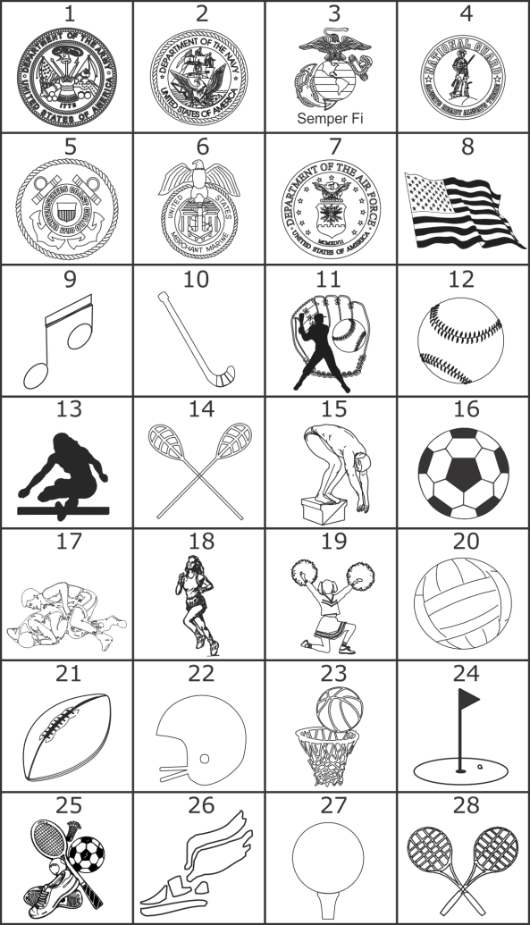

Compose your Message Here Clipart #_ _
Line 1 _ _ _ _ _ _ _ _ _ _ _ _ _ _ _ _ _ _ _ _
Line 2 _ _ _ _ _ _ _ _ _ _ _ _ _ _ _ _ _ _ _ _
Line 3 _ _ _ _ _ _ _ _ _ _ _ _ _ _ _ _ _ _ _ _
Line 4 _ _ _ _ _ _ _ _ _ _ _ _ _ _ _ _ _ _ _ _
Line 5 _ _ _ _ _ _ _ _ _ _ _ _ _ _ _ _ _ _ _ _
Line 6 _ _ _ _ _ _ _ _ _ _ _ _ _ _ _ _ _ _ _ _

Name:________________________________________________
Address:______________________________________________
_____________________________________________________
Phone:_______________________________________________
Email:________________________________________________

