Insert Your Program Name Here
Type a Theme/Saying Here
Honoring those who serve in times of crisis….
Fundraising Brick LLC
105 Industrial Drive
Hermann, MO 65041
Phone: 573-486-5515
Fax: 636-600-5352
Email: jenny@fundraisingbrick.com
Visit us at: www.fundraisingbrick.com
Type the Purpose of Your Fundraiser Here
Example of Memorial: In Honor of Police, Firefighters, And Military Personnel Who Serve Their Country And Their Communities.
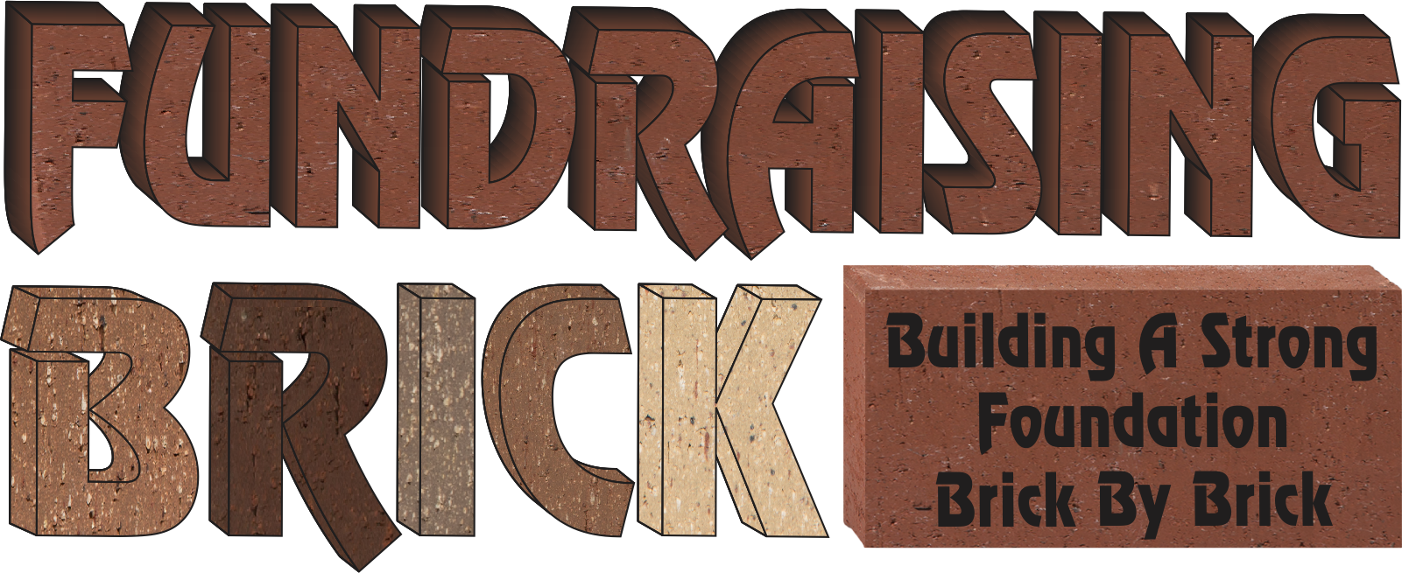
Insert picture, company logo, or graphic here.
Easily change the color theme to match your logo or ask Fundraising Brick to design you flyer/brochure.

Insert picture, logo, or graphic here or type text about your fundraising project

Insert picture, logo, or graphic here or type text about your fundraising project

Insert picture, logo, or graphic here or type text about your fundraising project

Insert picture, logo, or graphic here or type text about your fundraising project

Insert Your Title Here
Type a detailed description of your fundraising project here. Include details of how the project came about and what the project represents and how the funding will be used.
Laser Engraving Process
Laser Engraving is an environmentally natural process where the laser reacts with the properties in the bricks and tiles to create a life-long mark. No harmful chemicals, epoxies or paints are used to achieve contrast in the laser marking process.
Bricks are the original sustainable building material. As early as 7500 B.C., bricks have been found to be used in building. The original bricks were dried bricks, formed out of clay from the earth, or mud, and dried by the sun for long periods of time. The drying out of the clay or mud made the material strong enough to use and made whatever structure the people were building durable. In more modern times, the brick is usually a mix of natural materials (clay and shale) that has been ground, mixed with water, molded or hand-shaped, dried and then fired in large kilns as the final process.
What you get is a beautifully laser engraved brick or tile that is Green and was produced without placing harm on the environment.
BUY A BRICK
Leave your mark in history! Memorial Brick Costs
Insert picture, logo, or graphic here or type text about your project

4” X 8” Brick Paver (3 lines) $150
8” X 8” Brick Paver (6 lines) $250

(4” X 8” red brick 20 spaces per line –3 line limit)
(8” X 8” red brick 20 spaces per line –6 line limit)
There is also clip art available at no additional charge! For additional information on what is available please Contact Jennifer Stemmley at jenny@fundraisingbrick.com or call 573-486-5515
Compose your Memorial Message Below
Line 1 _ _ _ _ _ _ _ _ _ _ _ _ _ _ _ _ _ _ _ _
Line 2 _ _ _ _ _ _ _ _ _ _ _ _ _ _ _ _ _ _ _ _
Line 3 _ _ _ _ _ _ _ _ _ _ _ _ _ _ _ _ _ _ _ _
Line 4 _ _ _ _ _ _ _ _ _ _ _ _ _ _ _ _ _ _ _ _
Line 5 _ _ _ _ _ _ _ _ _ _ _ _ _ _ _ _ _ _ _ _
Line 6 _ _ _ _ _ _ _ _ _ _ _ _ _ _ _ _ _ _ _ _
Name: ______________________________________
Address: ______________________________________
______________________________________
Phone: ______________________________________
Email: ______________________________________

Method of Payment (check one):
□Check □Visa □MC □ Discover □Bill Me
Credit Card #:

Exp. Date: ____________________________________
Signature:_____________________________________
The (Organization- Insert your organization name here) wishes to thank our major sponsors: Type your sponsors here
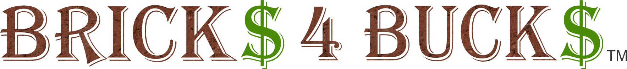
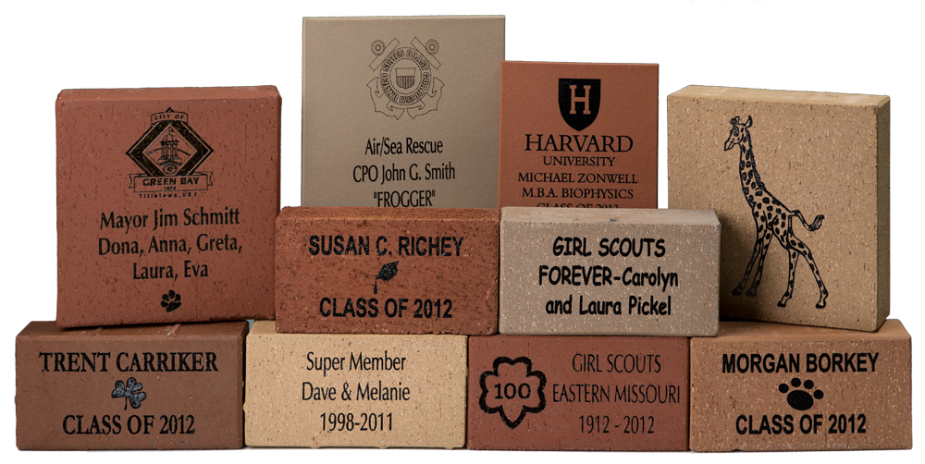
Insert pictures of engraved bricks here. Contact Fundraising Brick to receive your Free brick layout examples.

