Donations to the Enter Your Organization Name Here can be made by Check or Online. Checks need to be made payable to Enter Your Organization Name Here, and be mailed to: Enter Your Address Here

Email Orders To: (Hold down the Control key & click on the link below) Make sure you save this form and then attach it to the email.
Click Here to email this order form - save form to your computer and attach in the email
Brick Size Options
Regimental Red 4X8 Full Paver $200.00 (Set your price and choose your options)
Regimental Red 8X8 Full Paver $500.00 (Set your price and choose your options)
Regimental Red 8X8 Full Paver $1000.00 (Set your price and choose your options)
Method of Payment
Check Online (using Pay Pal) http://www.fundraisingbrick.com (this will change when web page is finished)

Name

Address Street

Address (City, State, Zip)

Phone Number

Email Address

Ordering Options - 3 lines of text with 20 characters per line
4X8” Commemorative Brick $200.00
Ordering Options - 6 lines of text with 20 characters per line
8X8” Commemorative Brick $500.00

Ordering Options - Up to 6 lines of text with 15 characters per line. The graphic will be displayed to the left of the text and centered from top to bottom on the brick. If you are ordering an 8X8 with a graphic, please submit the graphic along with the order form. Please provide a clear graphic with a 300DPI minimum. JPEG files are preferred.

8X8 Commemorative Brick with Custom Graphics $1000.00
Enter Your Text Here (All punctuation and spaces are part of the character count)

Text Line # | Enter Text Here | Enter Clipart # Here
Line #1
Line #2
Line #3
Line #4
Line #5
Line #6

All 4X8 & 8X8 Bricks will be laser engraved with the Zapf Humnst Font Z110H and characters will be 15mm tall.
Add Customized Clipart Selection Here
All you have to do is select which Clip Arts you want to offer from our list of over 300 and let Fundraising Brick handle the rest, we will generate a custom selection just for you.

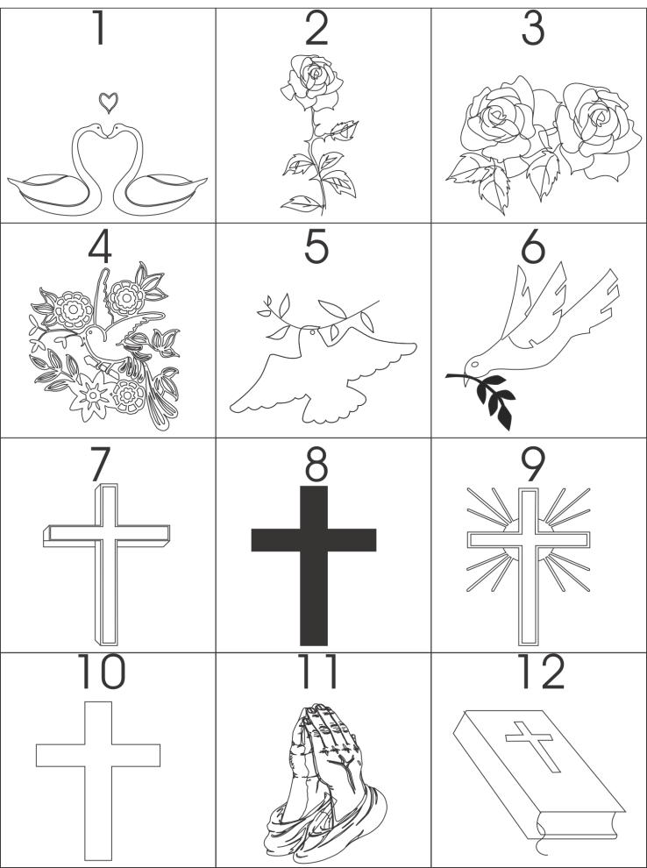
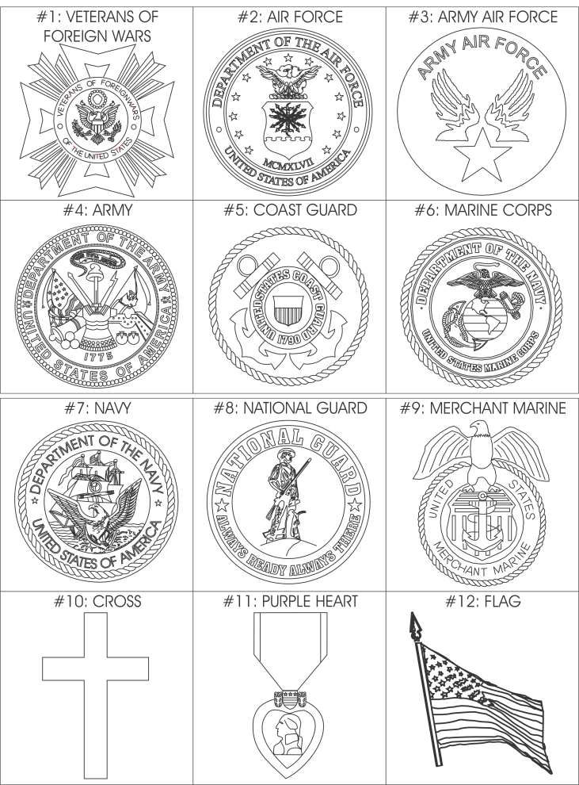
Examples

