(Enter Your Organization Name Here) Presents
The Engraved Brick Memorial Garden Program

NOTE: All highlighted text should be modified for your fundraising project

(Enter your organization name here) is planning to build a memorial garden outside of our building to be located by out Memorial Bench. The laser engraved memorial bricks will be on 4X8X2 ¼” Brick Paver Stones and will cost $250.00 each. You will be able to order up to three lines of text with 20 characters per line (this includes all punctuation and spacing). The engraved letters will be 15mm tall in the Zapf Humnst Font. If you are interested in purchasing a brick for the Memorial Garden, please put your name on the sign-up sheet provided. If you have any questions regarding the Memorial Garden, please contact (Enter contact name here) at (enter phone number here)

Laser Engraved Sample Brick
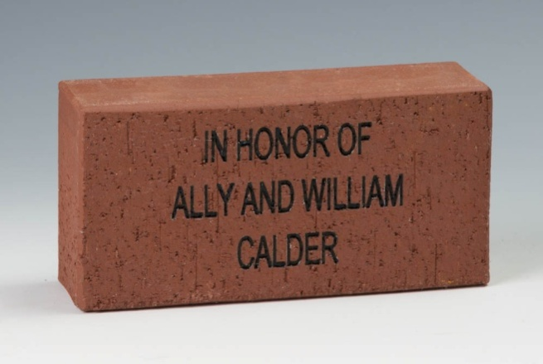

First & Last Names | First & Last Names | First & Last Names

