The press release should include "The 5 W's": Who, What, Where, When & Why

ENGRAVED BRICK CAMPAIGN PRESS RELEASE

FOR IMMEDIATE RELEASE – July 1, 2015 (change date to reflect date of sales open to donors)

Contact Info: Jennifer Stemmley, Foundation Administrator jenny@fundraisingbrick.com or (573) 486-5515 office, (573) 694-1127 cell (enter your organization info. Here)

ORGANIZATION NAME HERE “BRICK BY BRICK” FUNDRAISER change slogan or use this one.

Make a lasting tribute to family and friends through the brick fundraising campaign sponsored by the ORGANIZATION NAME HERE. “Achieving Excellence Brick by Brick (enter your brick campaign slogan here)” allows individuals to purchase laser engraved bricks for installation enter installation details here. Bricks purchased will fund (enter what the bricks will fund here). The first order will not be laid until construction is completed. The donation per brick is tax deductible (verify with your accountant that purchased bricks are tax deductible).

Each 4X8 brick can be engraved with up to three lines, 20 characters (including punctuation and spaces) per line. Each 8X8 brick can be engraved with up to six lines, 20 characters (including punctuation and spaces) per line. (Include other detail regarding brick purchased that your organization may have, such as corporate donations, replica brick, mini bricks, etc.) You can purchase just one paver or several. Engravings can be purchased in your name or the name of a friend or family member; in celebration of a birth, graduation, wedding or anniversary; in honor of a soldier or veteran; or in memory of someone you love. Honor a casual effort; commemorate a special occasion-the possibilities endless with our brick laser engraving technology. Businesses, firms and organizations are also encouraged to participate.

Bricks will continue to be sold until all spaces are filled. Brick orders are placed September 1 and March 1 (change dates or remove if you do not wish to inform your donors of order dates) of each year.

They may be purchased through the Fundraising Brick, 105 Industrial Drive Hermann MO 65041 or online at www.fundraisingbrick.com/onlineorders. For more information or to download an order form, visit www.fundraisingbrick.com.

Donate Today! Become a permanent part of ORGANIZAITON NAME HERE.
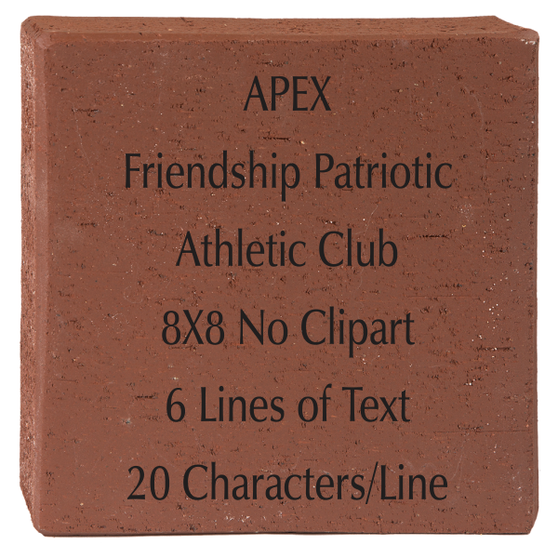
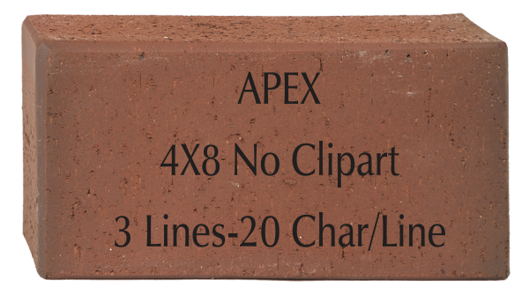INSERT BRICK
PICTURES HERE
(OPTIONAL)

